Planning Document

## **Business Requirements**

## **Statement of Need**

Students require a mobile and web application database that they can use to store data on art, mathematics and technology. This database must be able to contain each subjects articles, biographies, events and important notions. It needs to be able to be accessed by administrators, tutors and students with different levels of access.

## **Statement of solution**

As a team we discussed the need and came up with the solution of a MySQL database that would be able to meet all the requirements of the school. This database would enable students to browse articles by category, or by keyword, or by title. It would also include user permissions for admin and tutors.

**Planning**

## **Iteration 1 - Days 2-4**

Developing System Design Document

* Analyse data and Create SDD
* Create SDD Architecture
* Create SDD Database Model
* Advise SDD User Access, and user roles and permissions
* Suggest SDD UX Design

Trello Screenshots for tasks to complete:

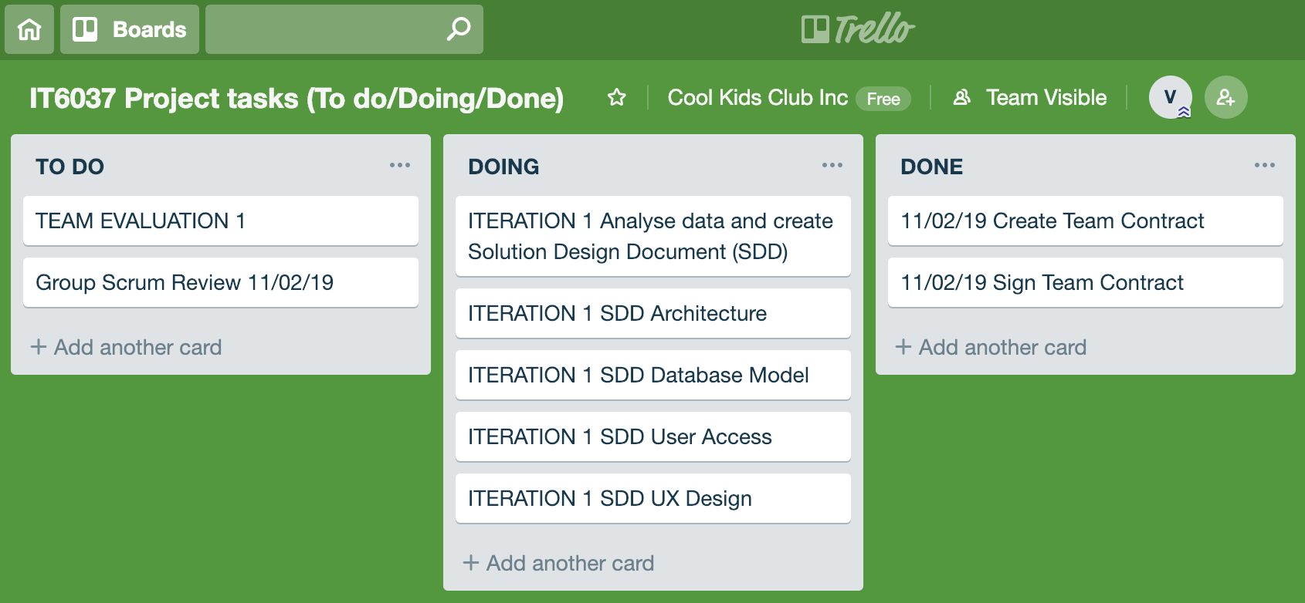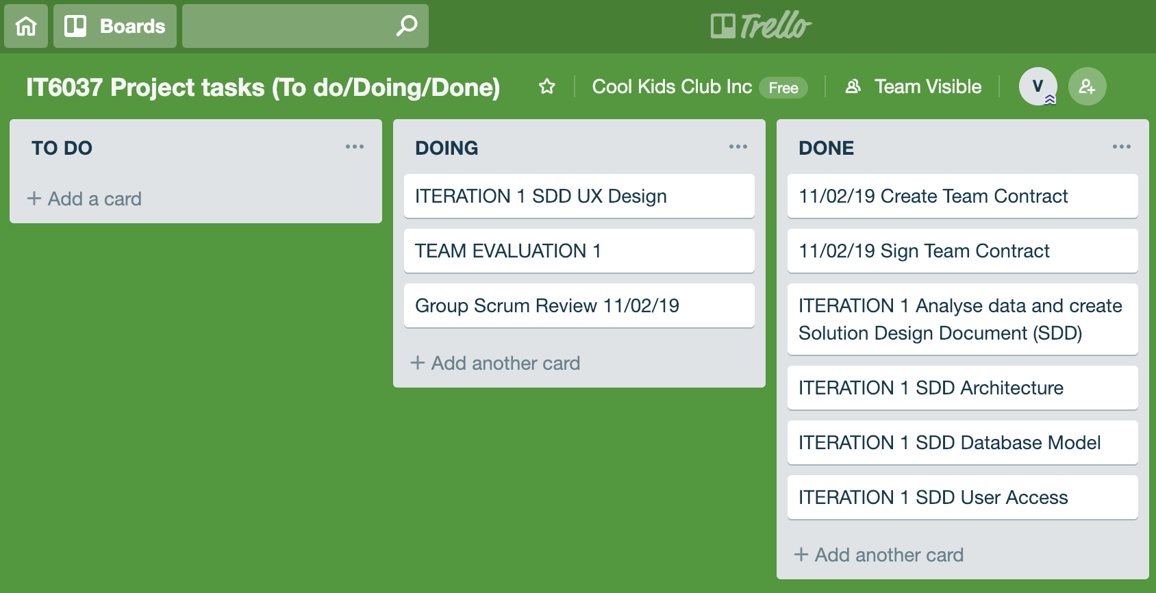

## 

## **Iteration 2 - Days 4-5**

Developing a Database

* Create Database in chosen DBMS
* Setup and Test GITHUB repository
* Create DB structure and enter test data

Trello Screenshots for tasks to complete:

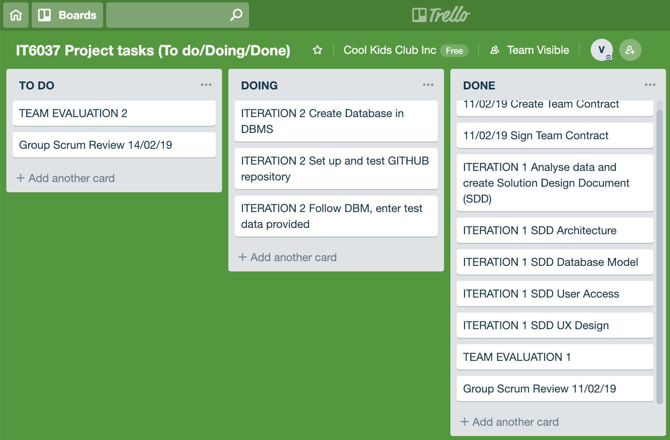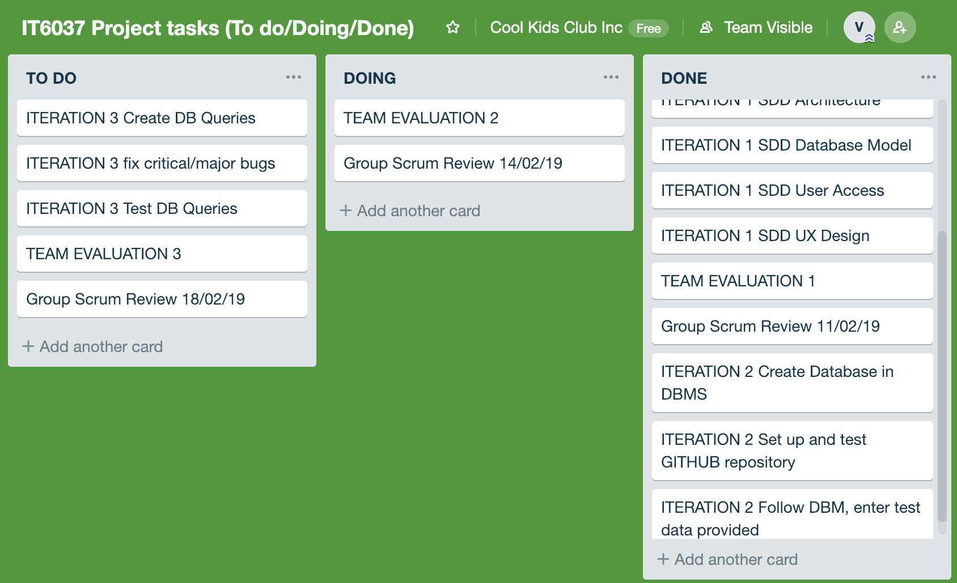

## **Iteration 3 - Days 5-6**

Develop Database Queries

* Create queries to browse data
* Test queries and fix errors

Trello Screenshots for tasks to complete:  
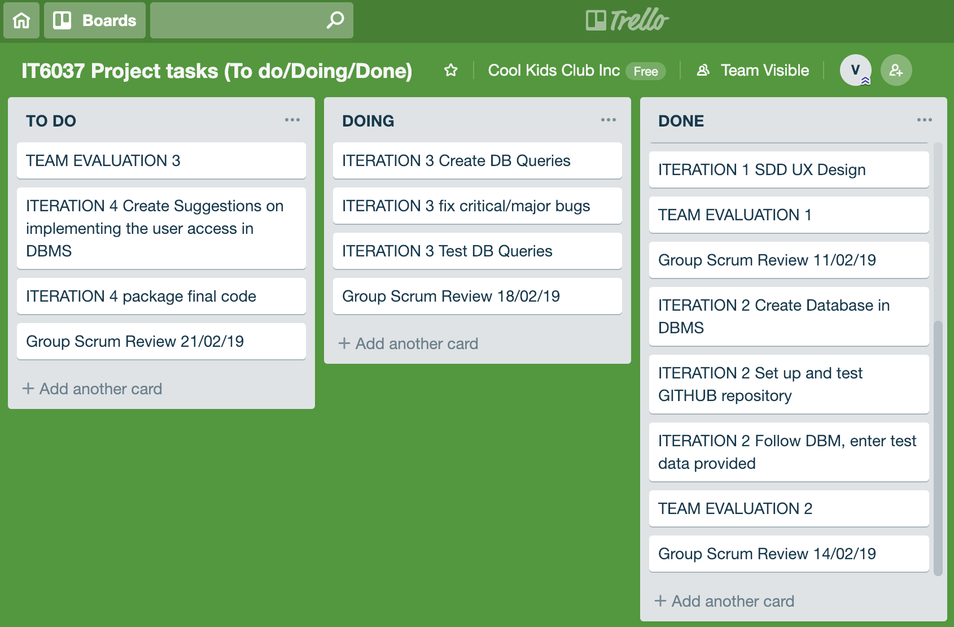

## **Iteration 4 - Days 6-7**

User Access Implementation Suggestions

* Create suggestions on implementing user access
* Describe the process to create users and assign permissions
* Package and submit code

Trello Screenshots for tasks to complete:

